**Steps to Uploading Your Code to GitHub**

Step 1

Create a New Repository in GitHub.com  
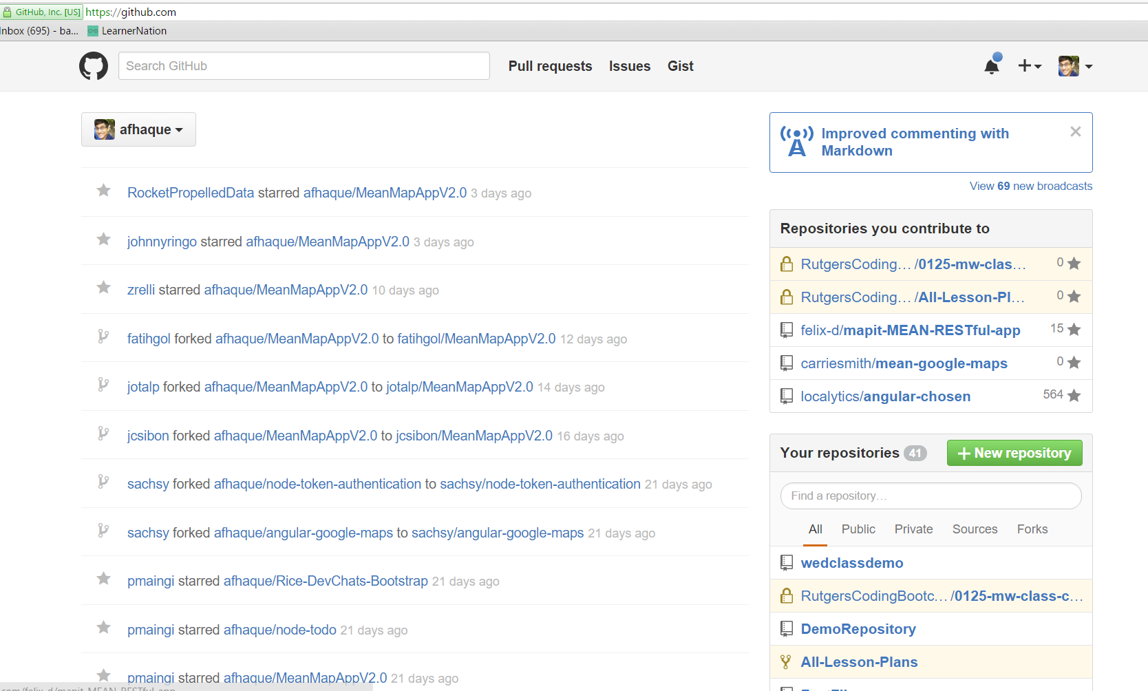

Step 2

Give the Repository a Name, set it to Public, and check “Initialize with readme”.

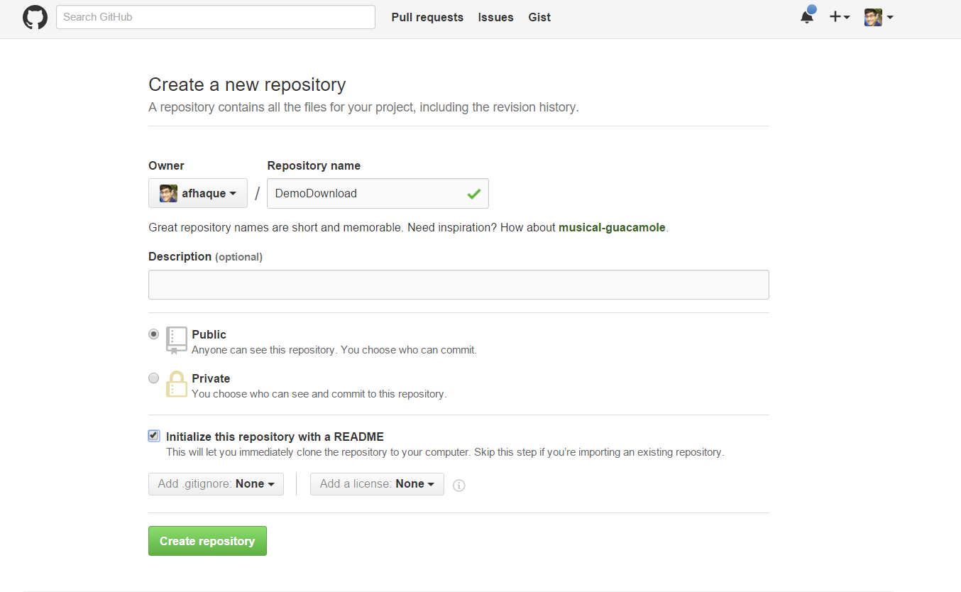

Step 3

Copy the link associated with your new repository from GitHub.

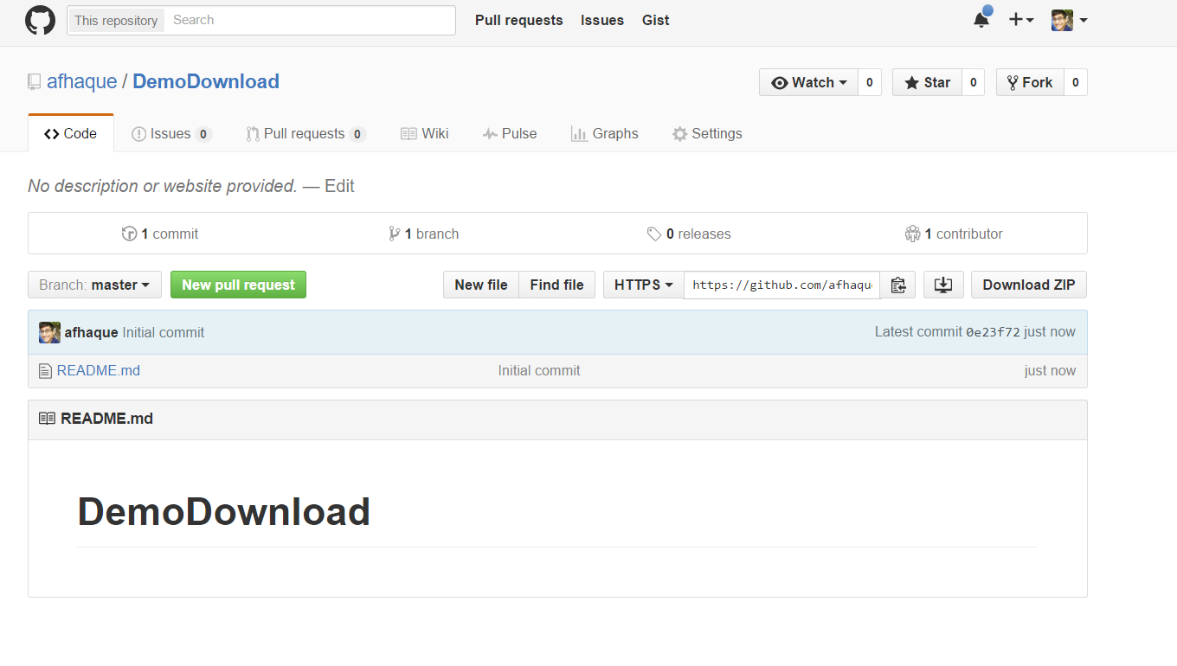

Step 4

Open the Bash (or Terminal) window.

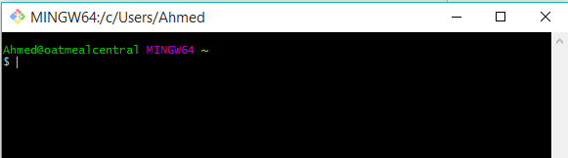

Step 5

Using Console, navigate into a folder where you’d like to download your code.

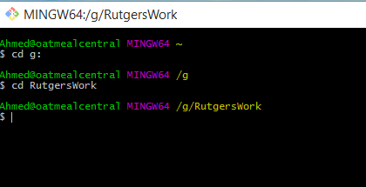

So, in my case, I’m navigating into a folder called RutgersWork in my g: Drive. In your case, it can be anywhere on your computer that you want to download code to.

Step 6

Next, in console – type the command: “git clone _________” and paste the link to your GitHub repository in that blank space. Your screen should look something like mine.

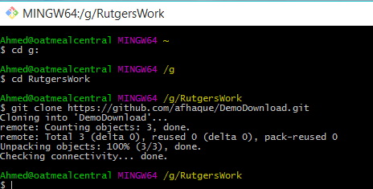

Step 7

Now if you navigate to that folder using file explorer, you will see a new folder with the same name as your repository has been downloaded.

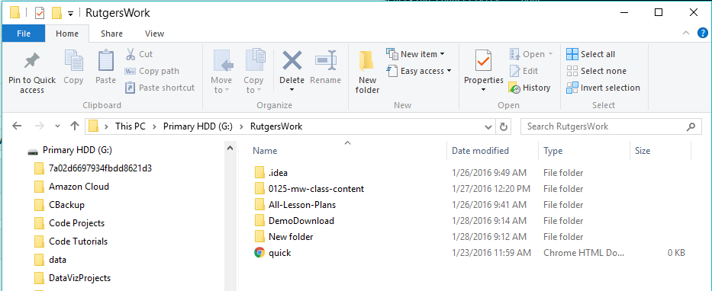

Go into that folder and you will see that it currently has a README file. This folder is now linked to Git.

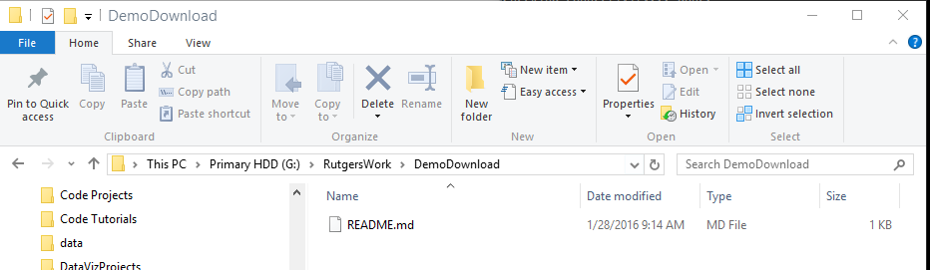

Step 8

Next create a new HTML file (or use an old HTML file). Save that file inside of your local repository folder.

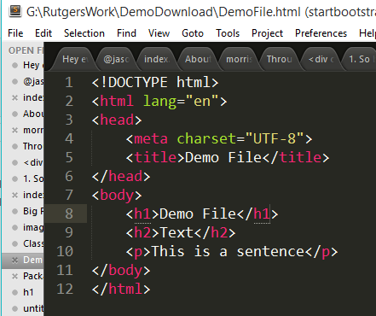

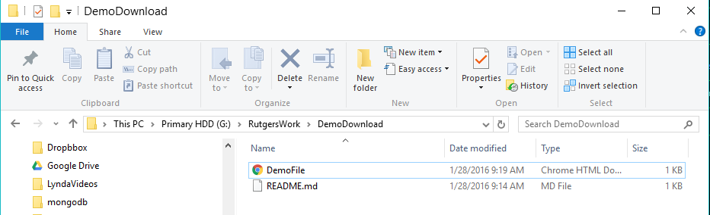

Step 8

In console, navigate into the folder associated with your code using the cd command.



Step 9

Next, type the command git add –A. This will tell git to notice the addition of the new html file. If this command worked you shouldn’t see anything happen.

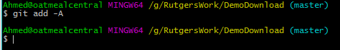

Step 10

Type the command, git commit –m “_____” and place a comment in the quotes. This will save your changes locally.

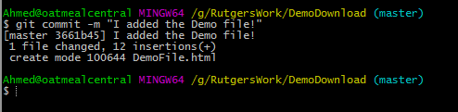

Step 11

Type the final command git push. Enter your GitHub username and password if asked.

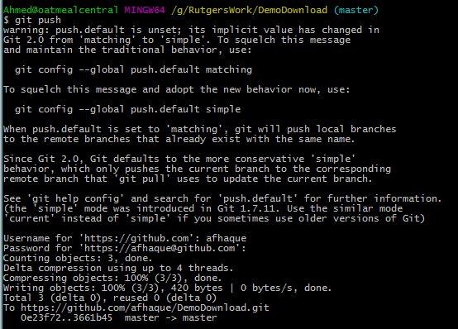

Step 12

Go back to the GitHub repository and you should see the file having been inserted!

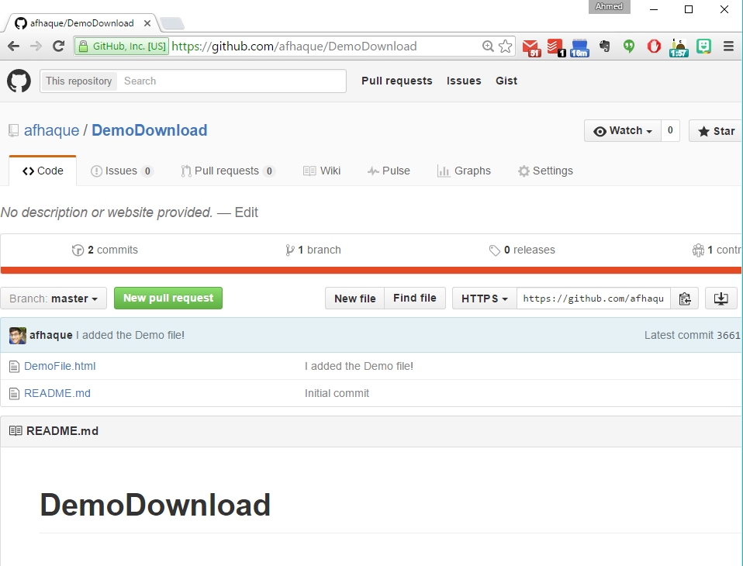

SUCCESS!!!!